BANK MARKETING BUSINESS ANALYTICS CASE STUDY
AnalystLab Africa Data Analytics Internship Program — Week 5
Bank Marketing Dataset | Python Analysis
Prepared as a business analytics case study focused on understanding term-deposit subscription behaviour and identifying actionable marketing opportunities.

1. Introduction
Banks use marketing campaigns to encourage existing and potential customers to purchase financial products. However, contacting every customer in the same way may not produce the same response. The purpose of this case study is to analyze the Bank Marketing dataset and identify patterns associated with customers subscribing to a term deposit. The analysis focuses on customer characteristics, contact methods, previous campaign outcomes and contact timing.
Python was used for data loading, cleaning, exploratory data analysis, descriptive statistics and visualization. The analysis combines customer distribution plots with subscription-rate analysis so that both the composition of the customer base and differences in campaign response can be considered.

2. Business Problem Statement
The business problem is to understand why some customers subscribe to a term deposit while others do not, and to identify customer and campaign characteristics associated with higher subscription rates.
The analysis addresses the following questions:
- What proportion of customers subscribed to a term deposit?
- What does the customer base look like in terms of age, job, education and marital status?
- Which customer segments have higher subscription rates?
- How do contact methods and previous campaign outcomes relate to subscription?
- Does subscription rate vary by contact month?
- How can the bank use these patterns to improve campaign targeting?

3. Dataset Description
The Bank Marketing dataset contains 11,162 customer records and 17 variables. The target variable is 'deposit', indicating whether a customer subscribed to a term deposit ('yes’ or 'no'). The dataset contains demographic, financial and campaign-related variables such as age, job, education, balance, contact, month and previous campaign outcome.
Measure | Result | Interpretation
Rows | 11,162 | Customer observations
Columns | 17 | Variables available for analysis
Subscribed | 5,289 (47.4%) | Customers who subscribed
Did not subscribe | 5,873 (52.6%) | Customers who did not subscribe
Missing values | 0 | No missing values detected
Duplicate rows | 0 | No duplicate records detected

4. Data Analysis Process
The analysis followed a structured exploratory-data-analysis process:
- Loaded the Bank Marketing CSV dataset into pandas.
- Inspected the dataset dimensions, column names and data types.
- Checked missing values and duplicate records.
- Reviewed descriptive statistics for numerical variables.
- Examined distributions of important categorical and numerical variables.
- Calculated overall and category-level subscription rates.
- Created visualizations using Matplotlib to identify trends and patterns.
- Translated the observed patterns into business insights and recommendations.

5. Exploratory Data Analysis

5.1 Overall Subscription Distribution
Out of 11,162 customers, 5,289 subscribed to a term deposit, while 5,873 did not. The overall subscription rate is 47.4%. This means that slightly more than half of the customers in the dataset did not subscribe.
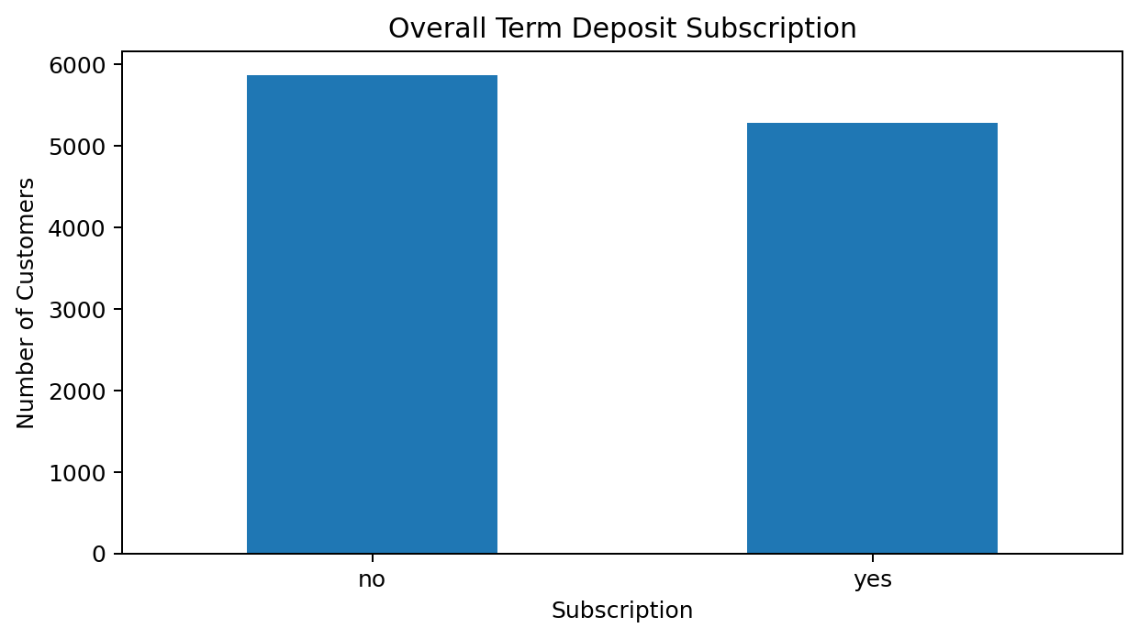
Figure 1. Overall distribution of term-deposit subscription.

5.2 Customer Age Distribution
The average customer age is 41.2 years, and the median age is 39 years. The age histogram shows the spread of customers across the age range and provides context for later segmentation analysis.
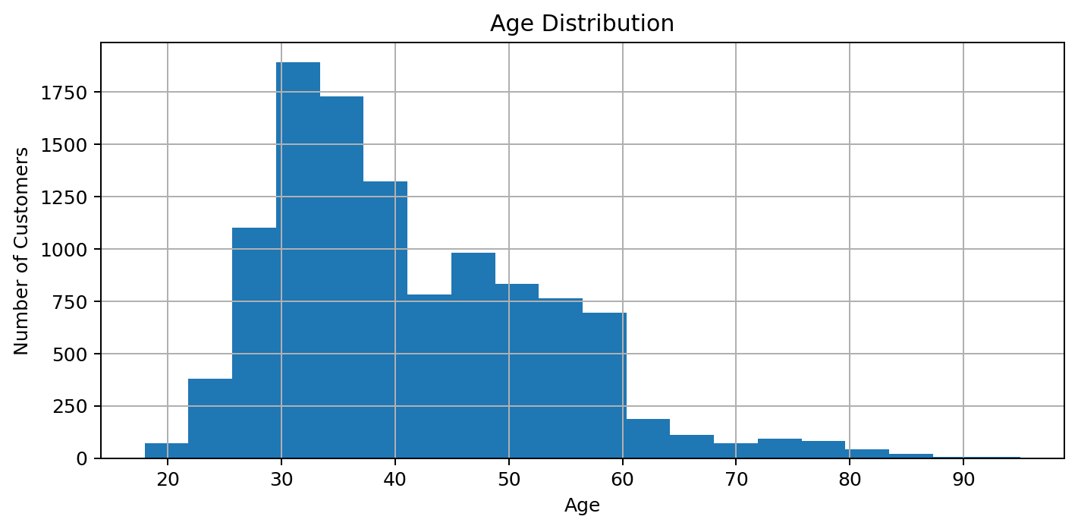
Figure 2. Distribution of customer ages.

5.3 Subscription Rate by Job
The job-level rate analysis shows meaningful differences between occupational groups. The highest observed job-level subscription rate is for student at 74.7%. This indicates that occupation may be useful when designing customer segments, although group size should also be considered.
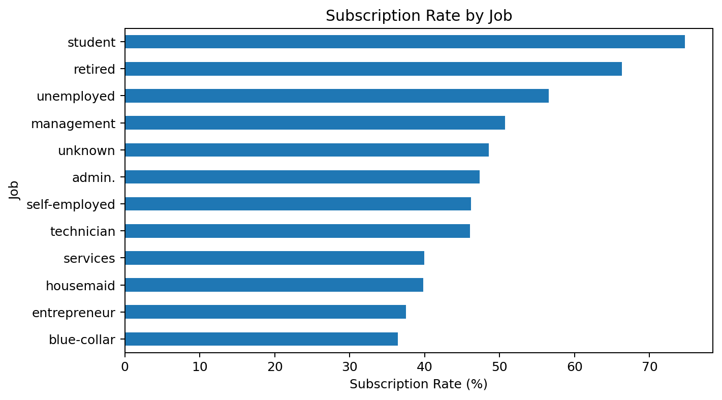
Figure 3. Subscription rate by job.

5.4 Subscription Rate by Education
The education analysis also shows variation in response. The highest education-category subscription rate is tertiary at 54.1%. Education can therefore be considered as one segmentation variable when planning campaign messaging.
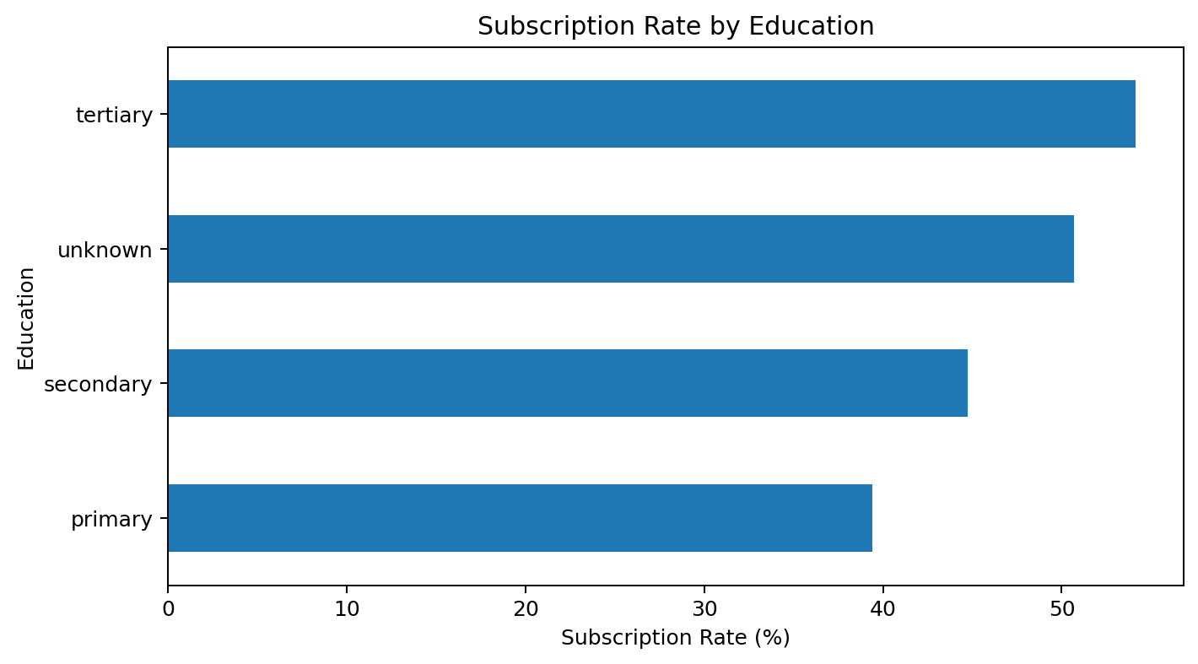
Figure 4. Subscription rate by education level.

5.5 Subscription Rate by Contact Method
Subscription rates differ across recorded contact methods. The highest observed rate is associated with cellular at 54.3%. This suggests that the communication channel may influence campaign response, but the descriptive analysis alone cannot establish that the channel caused the difference.
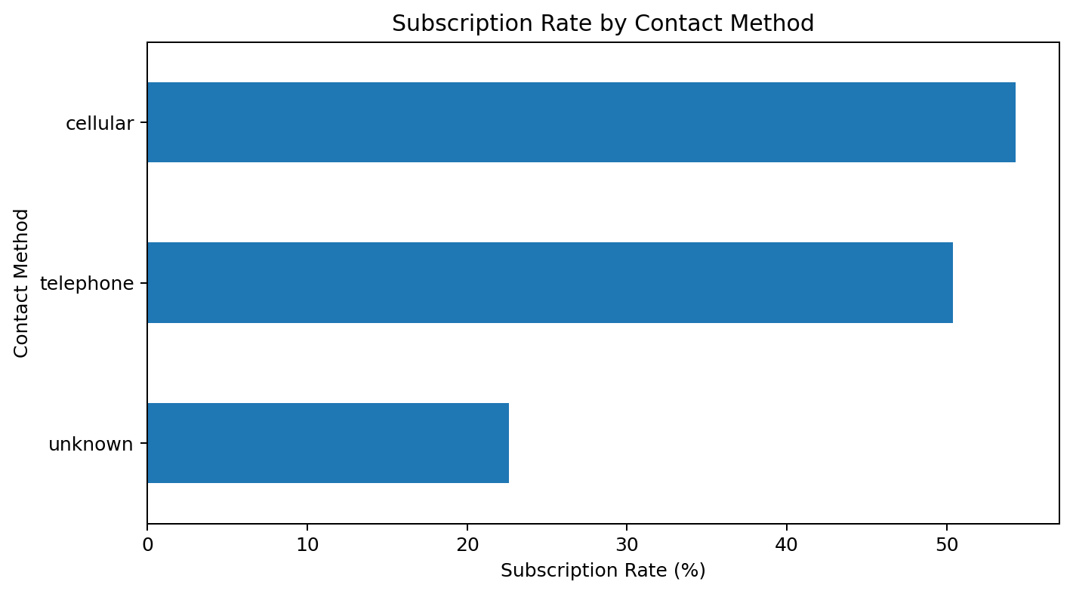
Figure 5. Subscription rate by contact method.

5.6 Subscription Rate by Previous Campaign Outcome
Previous campaign outcome is one of the strongest patterns in the analysis. Customers with a previous outcome of 'success' have a subscription rate of 91.3%. This suggests that prior campaign response can be a valuable indicator of customer engagement and should be considered in future targeting.
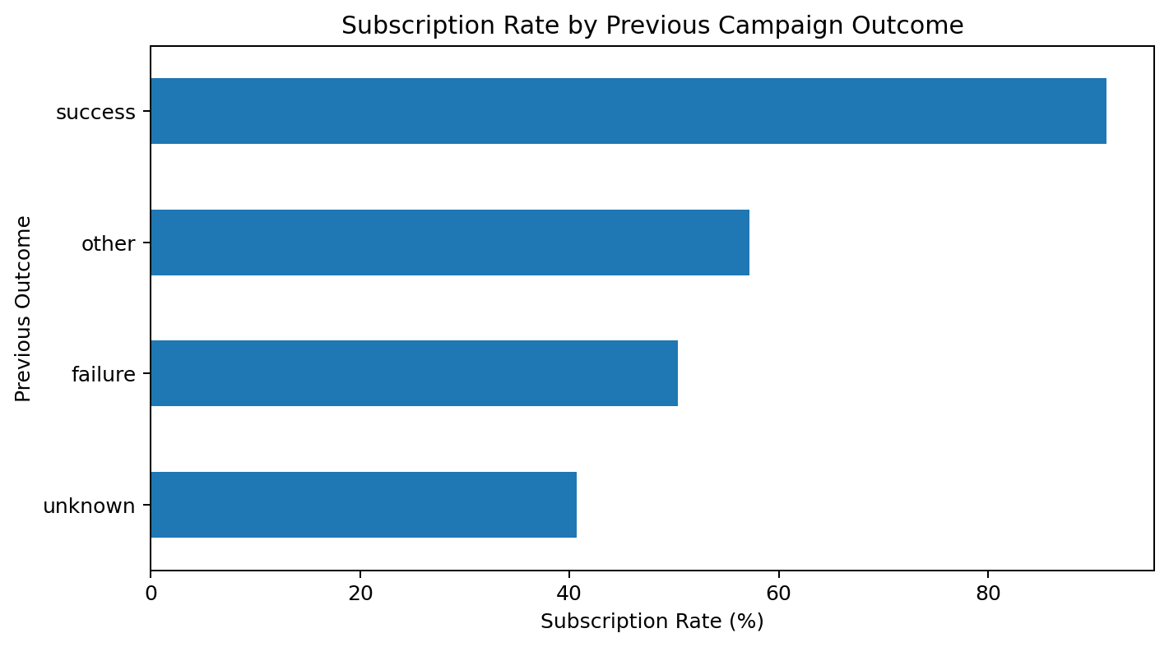
Figure 6. Subscription rate by previous campaign outcome.

5.7 Subscription Rate by Contact Month
Subscription rates vary considerably by contact month. The highest observed rate is in dec at 90.9%, while the lowest is in may at 32.8%. These differences suggest that campaign timing is worth investigating. However, monthly rates can also be affected by customer mix and campaign composition, so the pattern should not be interpreted as causal.
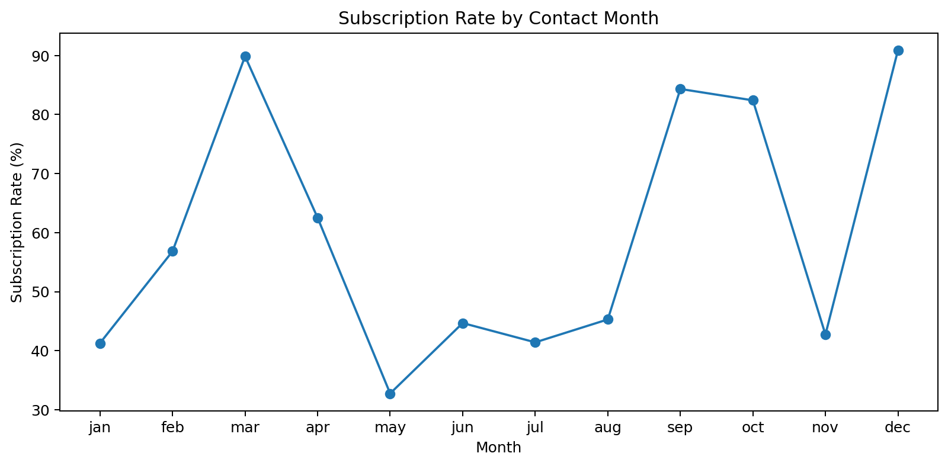
Figure 7. Subscription rate by contact month.

6. Key Findings
- The overall term-deposit subscription rate is 47.4%, with 52.6% of customers not subscribing.
- Customer age, occupation and education show substantial variation in the composition of the dataset.
- student has the highest observed job-level subscription rate at 74.7%.
- tertiary has the highest observed education-level subscription rate at 54.1%.
- cellular has the highest observed subscription rate among the recorded contact methods at 54.3%.
- The previous campaign outcome is a particularly useful segmentation variable, with 'success' showing the highest observed rate of 91.3%.
- Monthly subscription rates vary from 32.8% in May to 90.9% in dec.

7. Business Insights
The findings suggest that the bank should avoid treating its customer base as a single homogeneous group. Different customer segments respond differently to marketing campaigns, and the distribution of customers across those segments is also uneven.
The previous campaign outcome stands out as a practical indicator of customer engagement. Customers who have previously responded positively appear substantially more likely to subscribe again. This creates an opportunity to prioritize customers with demonstrated interest rather than relying only on broad demographic targeting.
The differences across contact methods and months also suggest that campaign execution matters. The bank can use these patterns as starting points for controlled tests, while recognizing that the current analysis is descriptive rather than causal.

8. Actionable Business Recommendations
1. Prioritize high-intent customers. Use previous successful campaign outcomes as an important targeting signal. Customers with demonstrated prior interest can receive more relevant follow-up communication.
2. Develop customer segments. Use occupation and education, together with other available customer information, to create more targeted campaign groups rather than using a single message for everyone.
3. Evaluate contact channels. Compare campaign performance by contact method and investigate why some channels show higher subscription rates. Use controlled testing before making large-scale channel changes.
4. Test campaign timing. The large differences between monthly subscription rates justify further testing of campaign timing. The bank should run structured experiments rather than assuming a particular month directly causes higher conversion.
5. Monitor conversion KPIs. Track overall subscription rate, subscription rate by segment, conversion by contact method, and conversion by campaign period. This will allow management to evaluate whether targeting improvements are working.

9. Challenges and Limitations
- The analysis is primarily descriptive and therefore identifies associations rather than proving causation.
- Some categories may contain different numbers of observations, so a high rate in a small group should be interpreted carefully.
- The 'unknown' previous-campaign-outcome category is large, which limits how precisely previous campaign history can be interpreted.
- Subscription rates by month may reflect differences in customer composition and campaign activity, not only timing effects.
- Further statistical modelling could be used to evaluate the simultaneous influence of multiple variables.

10. Conclusion
This case study analyzed 11,162 Bank Marketing customer records to understand factors associated with term-deposit subscription. The overall subscription rate was 47.4%, and the exploratory analysis showed differences across customer segments, contact methods, previous campaign outcomes and months.
The main business implication is that the bank can potentially improve campaign effectiveness by moving from broad outreach toward evidence-based customer segmentation. Previous campaign outcomes provide a particularly useful indicator of customer engagement, while occupation, education, contact method and timing provide additional segmentation opportunities.
The recommended next step would be to build a predictive model using the same variables and evaluate it with appropriate classification metrics. This would extend the current descriptive analysis from identifying patterns to estimating the probability that an individual customer will subscribe.

11. Skills Applied
- Python programming
- Pandas for data loading, cleaning and analysis
- Matplotlib for data visualization
- Exploratory Data Analysis (EDA)
- Descriptive statistics
- Categorical segmentation and subscription-rate analysis
- Business insight generation
- Data-driven recommendations

